PRODUCT SPECIFICATION

Accelink File No. | :
Accelink File Ver. | : | Ver <1.0>
Customer | :
Product Name | : | OSW-11(12,22B)UM-XXX-XX-X-S-XX/XX
<5> pages in total (Include Cover)
 | Drafter | Reviewer | Approver | Customer Confirm
Signature | Dahai.Zhou
Date | 2009-7-22

INDEX
1 DESCRIPTION 3
1.1 Product Function 3
1.2 Related Product List 3
2 OPTIC SPECIFICATION 3
3 OPERATION/STORAGE TEMPERATURE/HUMIDITY 3
4 PIGTAIL AND CONNECTOR 3
5 MECHANICAL DRAWINGS 4
6 OPTIC PORTS AND ELECTRONIC PINS DEFINITION 4
7 FIBER LENGTH 5
8 LABEL DEFINITION 5

Document History
VER. & STATUS | DATE | DESCRIPTION OF CHANGE | APPROVER
1.0-draft | 2009-5-5 | First Drafted
1.1-modify | 2009-7-22 | Change notes

1 DESCRIPTION

1.1 Product Function
Ultra Mini 1x1(1x2,2x2B) Optical Switch.

Related Product List
N/A

OPTIC SPECIFICATION
Table 1 Optical Specifications
NO | Parameter |  |  | Unit | Specifications
NO |  |  |  | Unit | Min | Typical | Max
2.1 | Operating Wavelength |  |  | nm | 1290~1330 AND/OR 1525~1610
2.2 | Insertion Loss¹ |  | 1x1 | dB |  |  | 0.8
2.2 |  |  | 1x2 | dB |  |  | 0.8
2.2 |  |  | 2x2B | dB |  |  | 0.9
2.3 | Insertion Loss Uniformity |  |  | dB |  |  | 0.25
2.4 | Return Loss |  |  | dB | 45
2.5 | Polarization Dependent Loss |  |  | dB |  |  | 0.07
2.6 | Wavelength Dependent Loss |  |  |  |  |  | 0.2
2.7 | Temperature Dependent Loss |  |  |  |  |  | 0.2
2.8 | Crosstalk |  |  | dB | 55
2.9 | Repeatability |  |  | dB |  |  | ±0.02
2.10 | Switch Time |  |  | ms |  |  | 4
2.11 | Durability |  |  | times | 10⁷
2.12 | Switch Voltage |  |  | V | 4.5 |  | 5.5
2.13 | Switch Current | Latching |  | mA |  | 22 | 25
2.13 | Switch Current | Non-latching |  | mA |  | 33 | 35
2.14 | Power Handling |  |  | mW |  |  | 500
Note：
- Test over the specified wavelength range(1290~1330nm bandwidth or 1525~1610nm bandwidth), operating temperature range(-5°C~+65°C), and all states of polarization.

OPERATION/STORAGE TEMPERATURE/HUMIDITY
Table 2 Environmental conditions
NO | Parameter | Specifications | Units | Note
3.1 | Operating temperature | -5~+65 | °C
3.2 | Operation Humidity | 5~95 | %RH
3.3 | Storage Temperature | -40~+85 | °C
3.4 | Storage Humidity | 5~95 | %RH

PIGTAIL AND CONNECTOR
Table 3 Pigtail and connector type/length
NO | Code | Parameter | Specifications | Unit
4.1 | 1 | Fiber Type | SMF-28e
4.2 | 2 | Pigtail type | 250μm bare fiber or 900 μm loose tube | mm
4.3 | 3 | Pigtail Length (All Port) | Customer defined | m
4.4 | 4 | Optical Connector (All port) | Customer defined

MECHANICAL DRAWINGS
Figure 1 Mechanical Drawings
Type 1:Metal tube with hot shrink tube
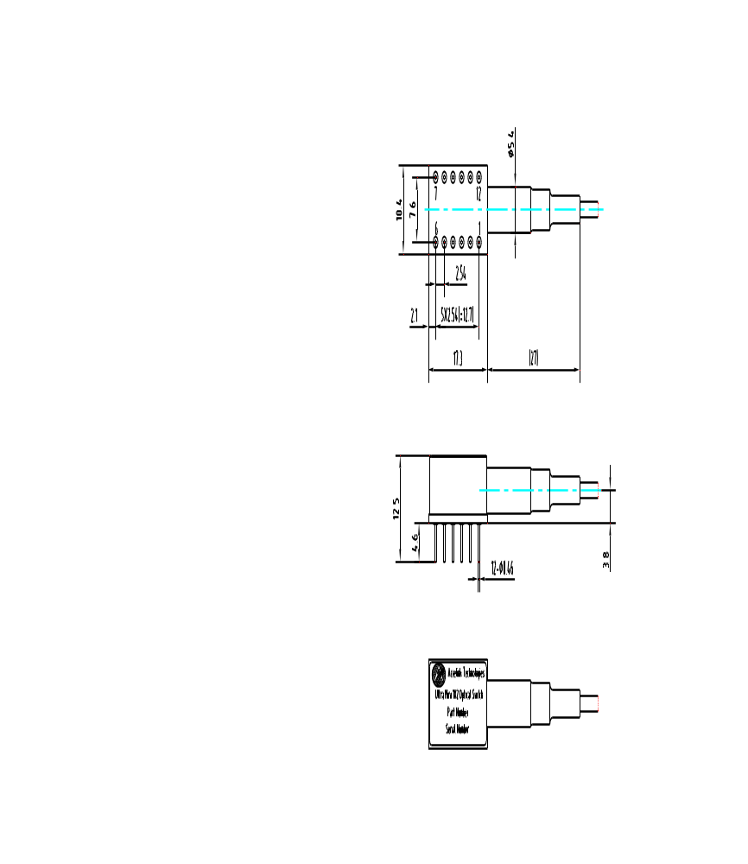

Type 2:Hot shrink tube
Unit: mm
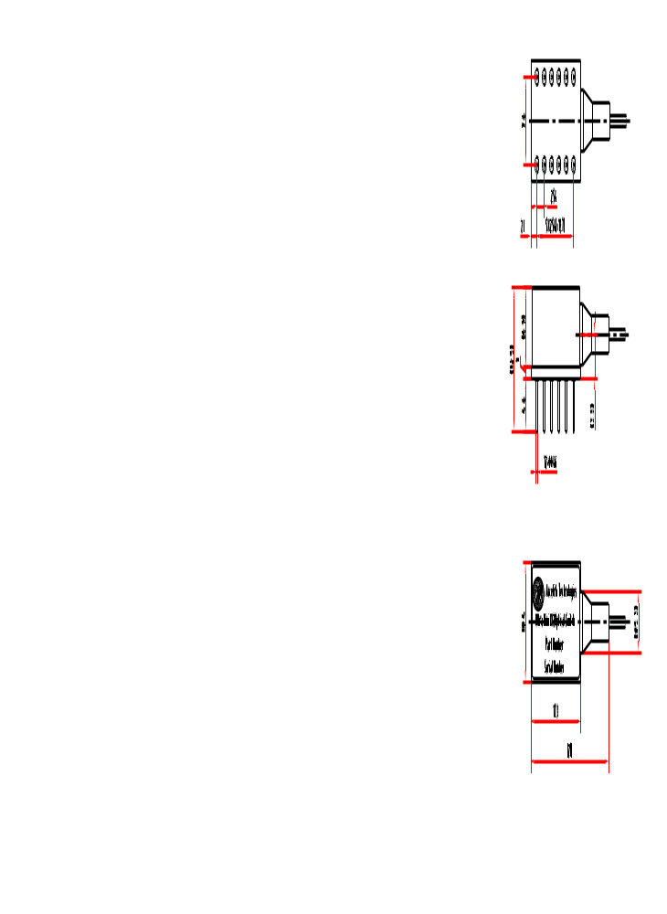

OPTIC PORTS AND ELECTRONIC PINS DEFINITION
Table 4 Optical Ports and Electronic Pins Definition
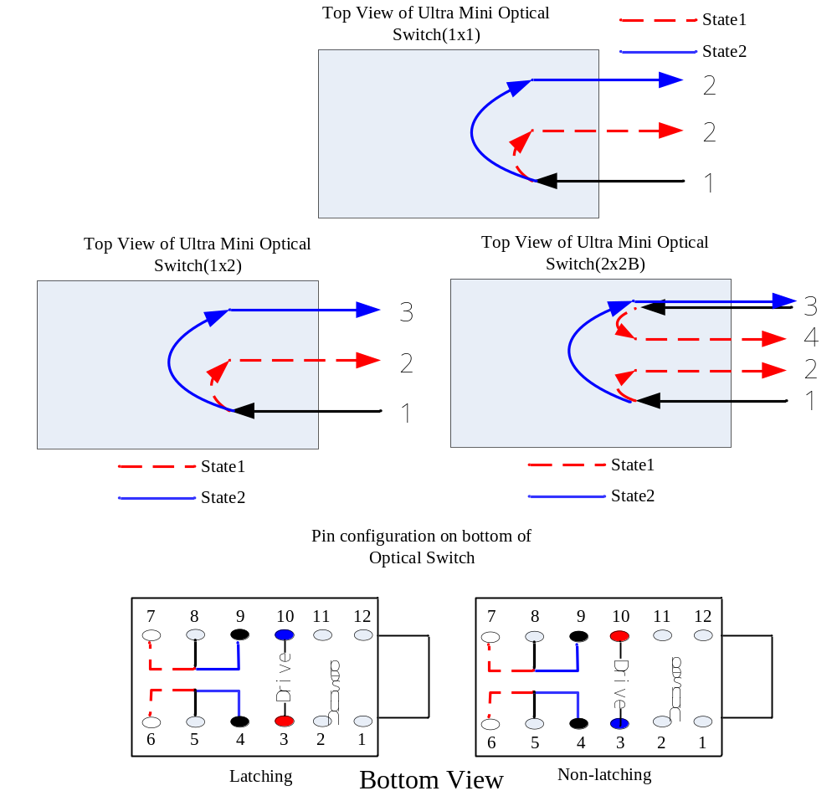
Type | Light Path |  |  | Drive pin |  | monitor
Type | 1x1 | 1x2 | 2x2B | 3 | 10 | 8-7  5-6 | 8-9  5-4
Latching | 1－2 | 1－2 | 1－2/3－4 | +5VDC | GND | close | open
Latching | - | 1－3 | 1－3 | GND | +5VDC | open | close
Non-latching | 1－2 | 1－2 | 1－2/3－4 | +5VDC | GND | close | open
Non-latching | - | 1－3 | 1－3 | GND | GND | open | close

FIBER LENGTH

Figure 2 Fiber Length Definition

Fiber length

LABEL DEFINITION
Figure 3 Label Definition
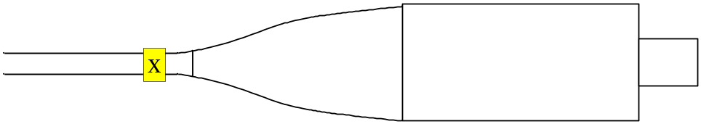
X=1, 2, 3
Ordering Information
OSW-
 | Type | Wavelength | Fiber Type | Fiber Length | Relay Type | Fiber Mode | Connector
 | 11UM=1×1  12UM=1×2  22BUM=2×2 Blocking | 850=850  131=1310  155=1550  135=1310&1550 | 025=SMF-28e 250um  09=SMF-28e with 900um loose tube | 0.5=0.5M  1=1.0M  Customer defined.  .  . | L=Latching  N=Non-latching | S=Single Mode  M=Multi-Mode | 00=None  FC/PC  FC/APC  SC/PC  SC/APC  MU  LC  .  .  .

